**ITSE 1330 – Intro to C#**

**Module 8 - Project 8**

**There are 3 projects for this Module. Place all 3 project folders in a folder called FirstnameLastnameCSMod8. When you are done with both projects, zip the folder and submit via Moodle. DO NOT ZIP EACH INDIVIDUAL PROJECT, only the outer folder.**

*Create a Windows Forms application named* ***FirstNameLastName8A***

*Save the application in the FirstnameLastnameCSMod8 folder.*

Create a class named Car that has the following properties:

* Year—The Year property holds the car’s year model.
* Make—The Make property holds the make of the car.
* Speed—The Speed property holds the car’s current speed.

In addition, the class should have the following constructor and other methods:

* constructor—The constructor should accept the car’s year and model and make them as arguments. These values should be assigned to the backing fields for the object’s Year and Make properties. The constructor should also assign 0 to the backing field for the Speed property.
* Accelerate—The Accelerate method should add 5 to the Speed property’s backing field each time it is called.
* Brake—The Brake method should subtract 5 from the Speed property’s backing field each time it is called.

Demonstrate the class in an application that creates a Car object. The application’s form should have an Accelerate button that calls the Accelerate method and then displays the car’s current speed each time it is clicked. The application’s form should also have a Brake button that calls the Brake method and then displays the car’s current speed each time it is clicked. Add a working Exit button.

Example Form:

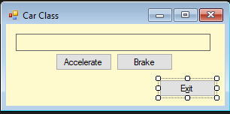

*Create a Windows Forms application named* ***FirstNameLastName8B***

*Save the application in the FirstnameLastnameCSMod8 folder.*

A university has the following dormitories:

* Allen Hall $1,500 per semester
* Pike Hall $1,600 per semester
* Farthing Hall $1,800 per semester
* University Suites $2,500 per semester

The university also offers the following meal plans:

* 7 meals per week $ 600 per semester
* 14 meals per week $1,200 per semester
* Unlimited meals $1,700 per semester

Create an application that allows the user to select a dormitory and a meal plan. The application should show the total charges in a label (Include dorm charges, meal charges and total charges properly formatted). Add a Clear button to delete text in label. Add a working Exit button.

Example Form:

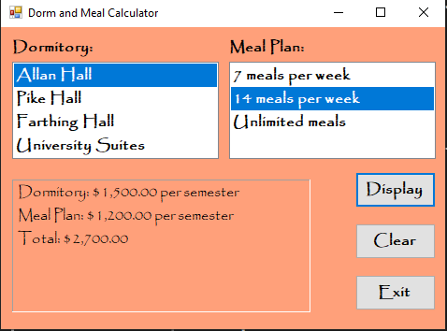

*Create a Windows Forms application named* ***FirstNameLastName8C***

*Save the application in the FirstnameLastnameCSMod8 folder.*

Create an application with a class named PersonEntry. The PersonEntry class should have properties for a person’s name, e-mail address, and phone number.

Create a text file that contains the names, e-mail addresses, and phone numbers for at least five people.

When the application starts, it should read the data from the file and create a PersonEntry object for each person’s data. The PersonEntry objects should be added to a List, and each person’s name should be displayed in a list box on the form. When the user selects a name from the list box, a message box should appear displaying that person’s name, e-mail address, and phone number. Add a clear button to clear the label. There should be a working Exit button.

Example Form:

